**19CSE301 - COMPUTER NETWORKS**

**Lab Assignment**

**Networking Commands**

* **R.Abhinav**
* **CB.EN.U4CSE19453**

**1.ping:**

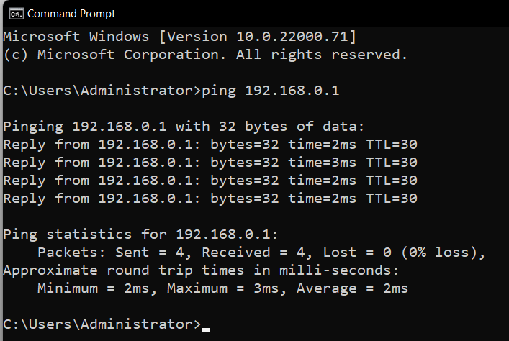

**(i) ping /4 192.168.0.1 :**

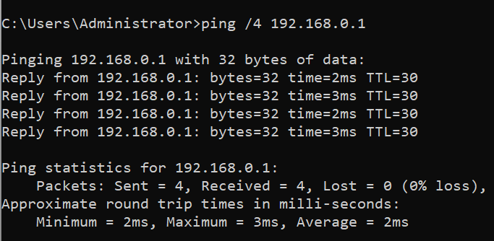

**(ii) ping /r 192.168.0.1 :**

To ping the destination 192.168.0.1 and record the route for 4 hops, type:

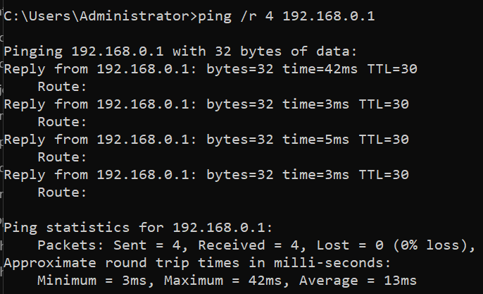

**(iii)** **ping /a :**

To ping the destination 192.168.0.1 and resolve 192.168.0.1 to its host name, type:

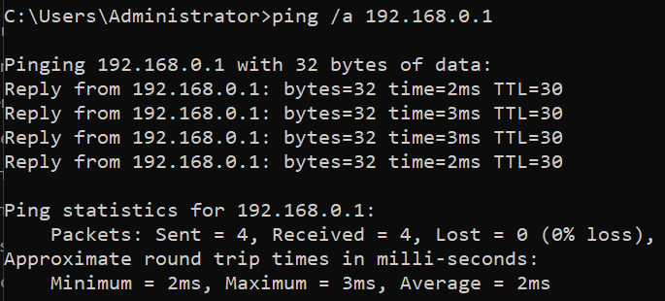

**(iv)** **ping /n 10 /l 1000 192.168.0.1**

To ping the destination 192.168.0.1with 10 echo Request messages, each of which has a Data field of 1000 bytes, type:

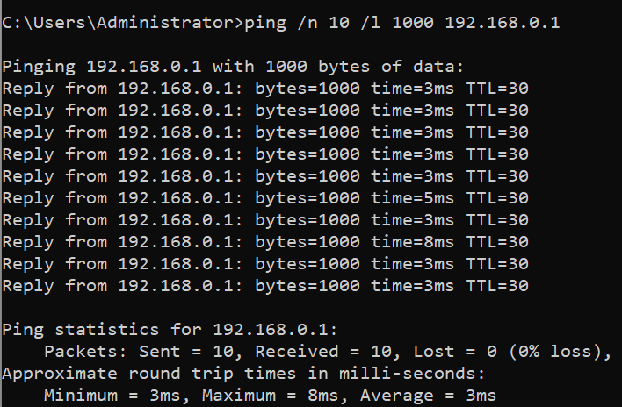

**2.) ipconfig:**

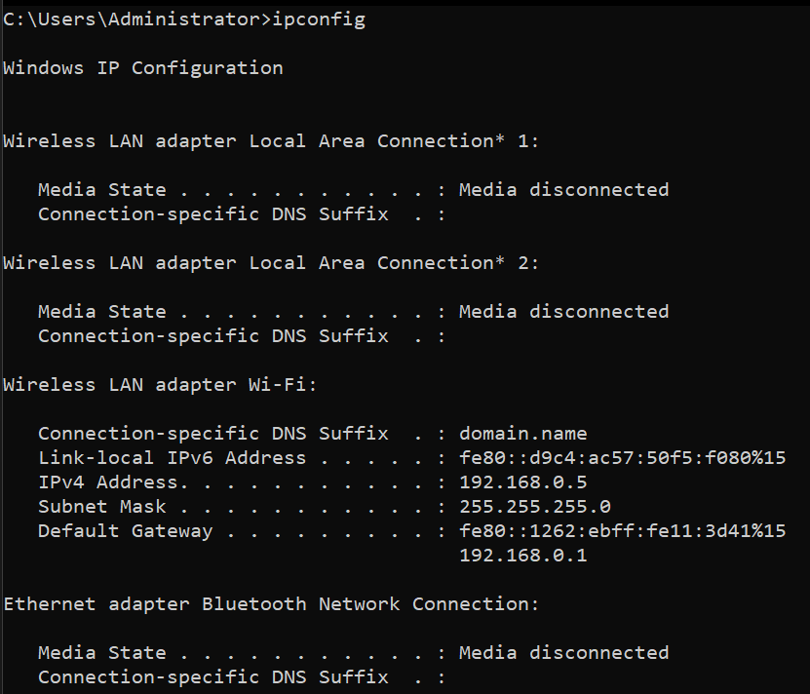

**(i) ipconfig /all :**

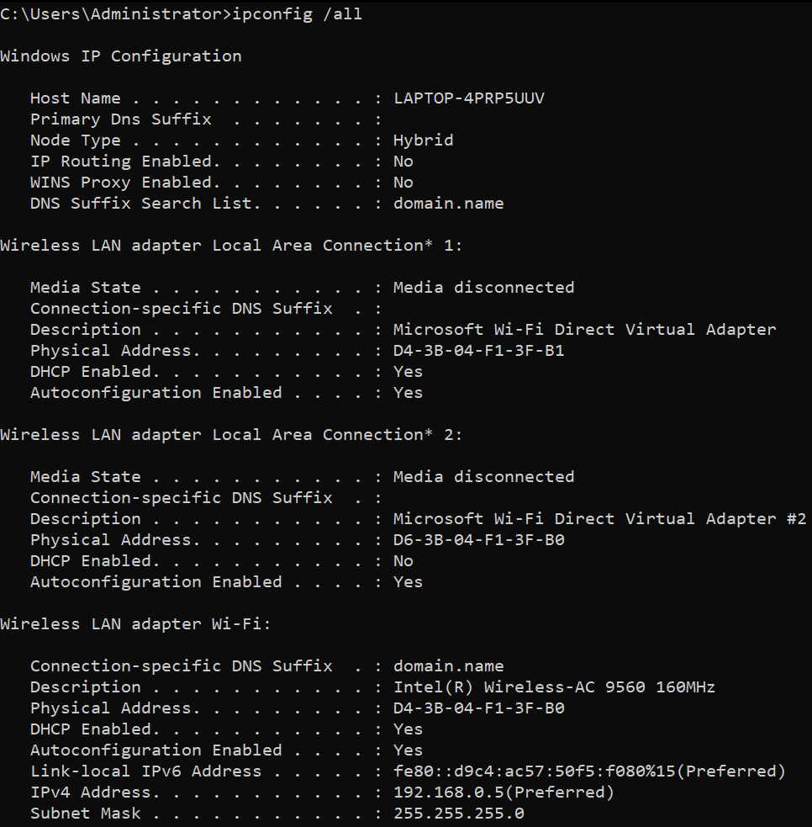

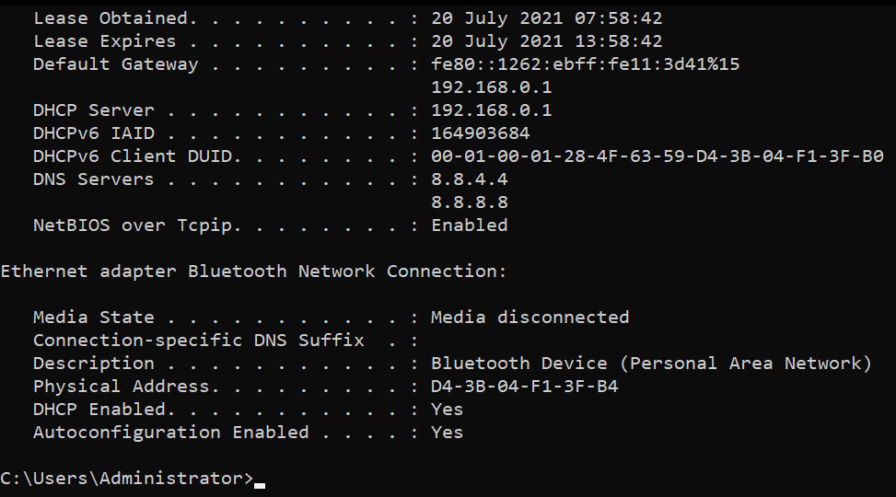

**(ii) ipconfig /renew :**

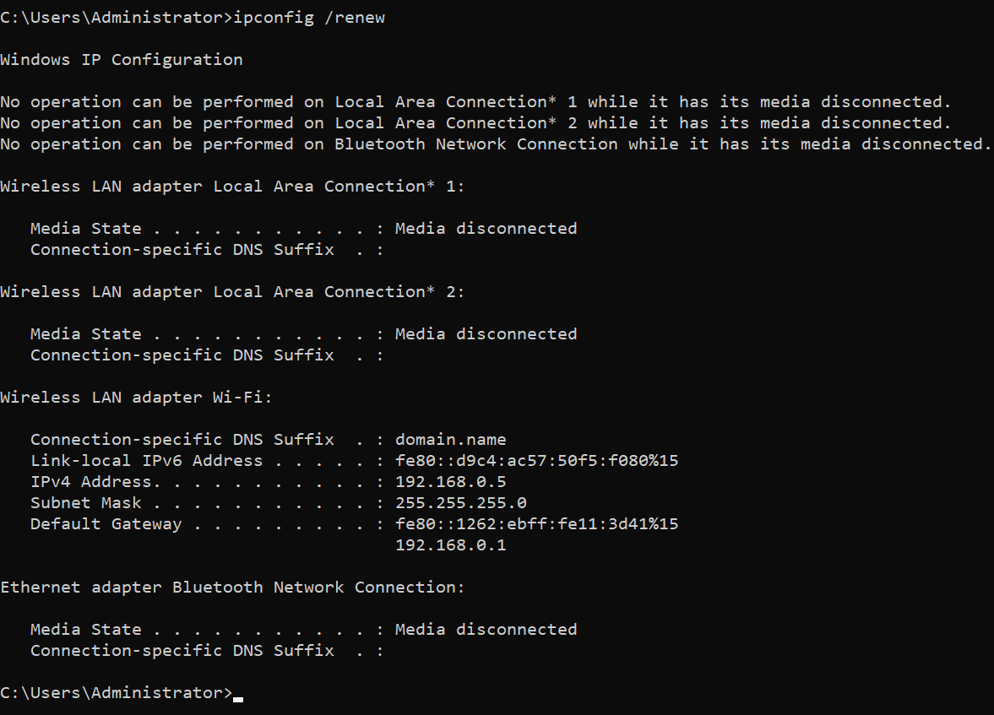

**(iii) ipconfig /release :**

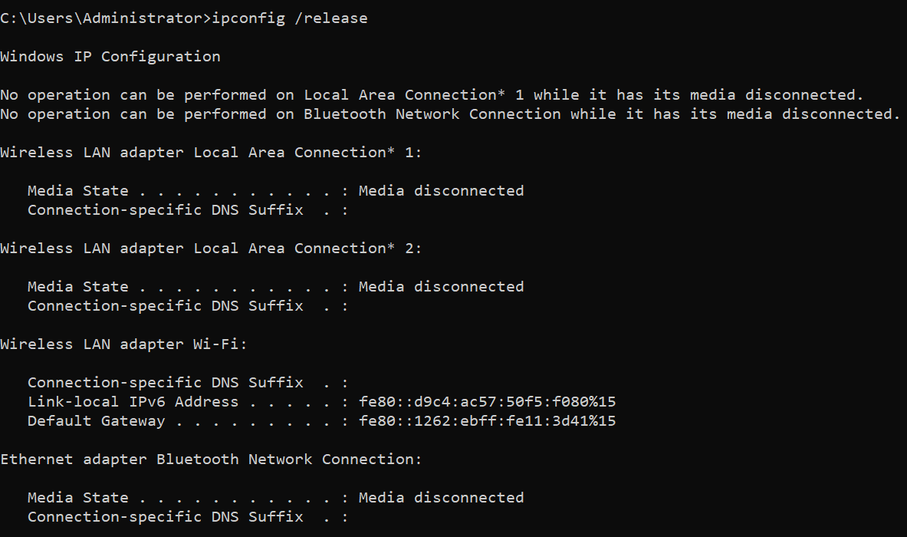

**(iv) ipconfig /flushdns:**

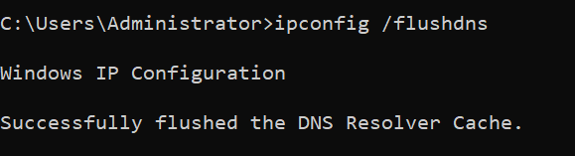

**(v) ipconfig /displaydns :**

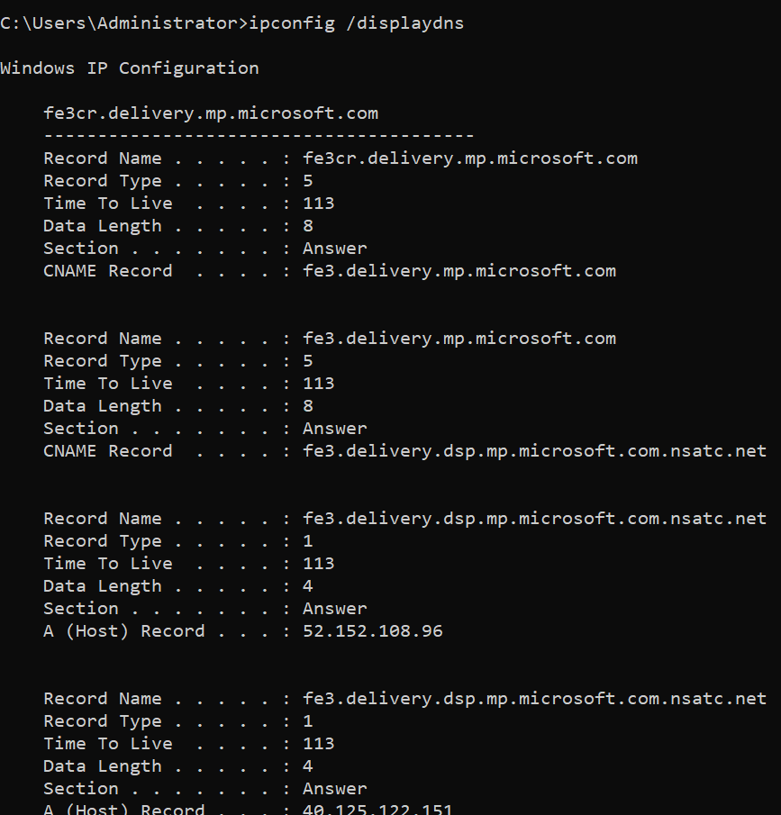

**3) getmac :**

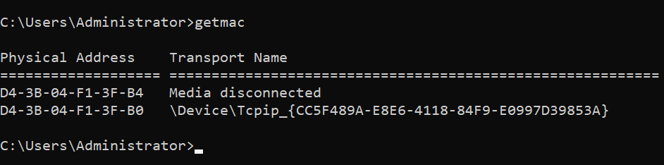

**(i) getmac /v :**

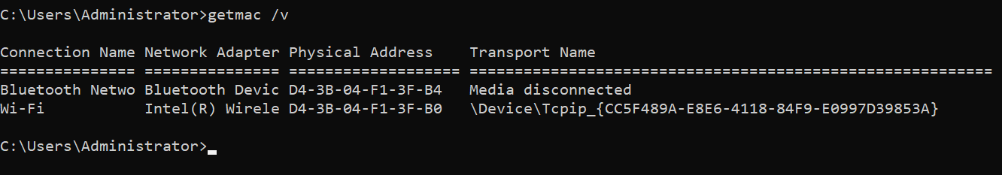

**(ii) getmac/nh :**

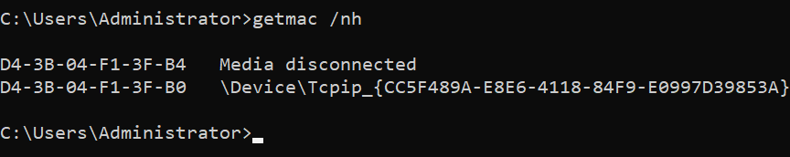

**(iii) getmac /fo table /v**

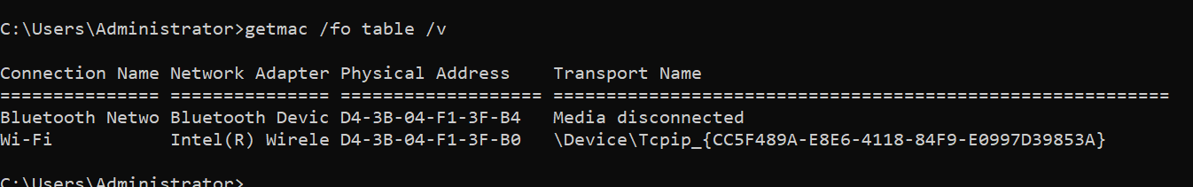

**(iv) getmac /? :** help

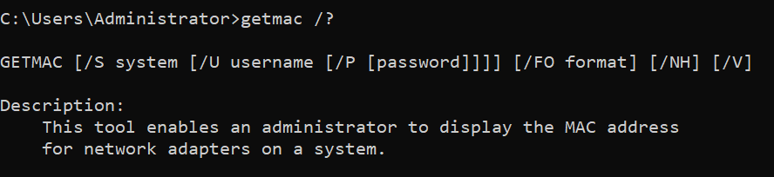

**4) tracert :**

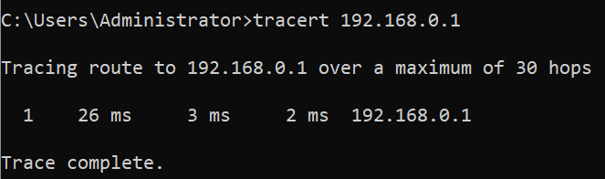

1. **tracert -d addr :**

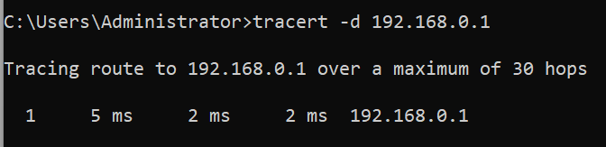

1. **tracert /j :**

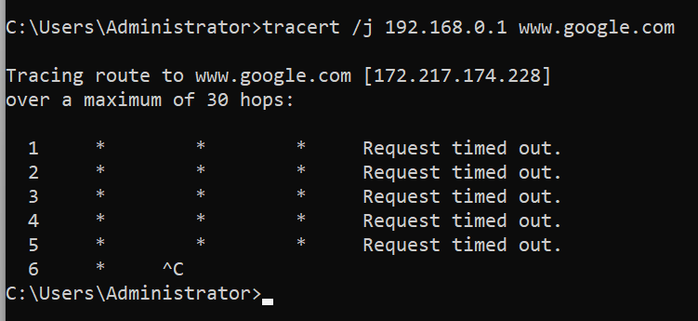

**(iii) tracert /4 [addr] :**

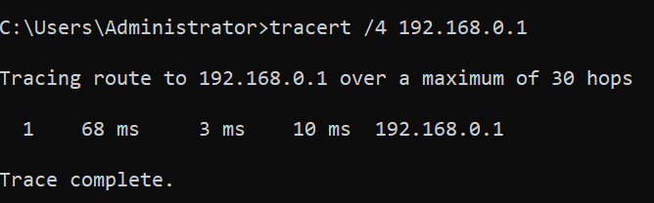

**5) arp :**

**(i) arp -a :**

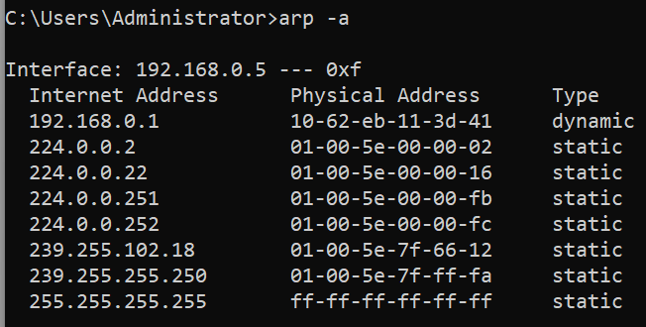

**6.) pathping :**

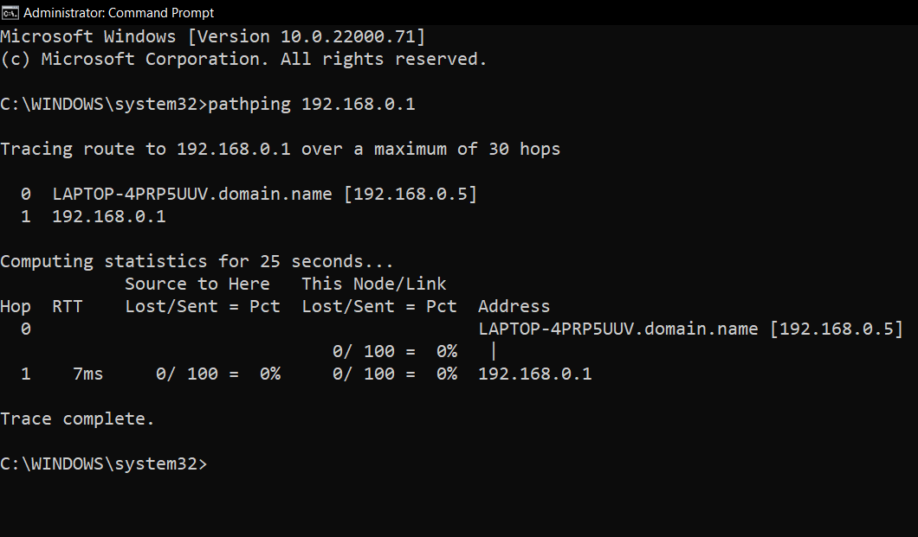

**(ii) pathping /n:**

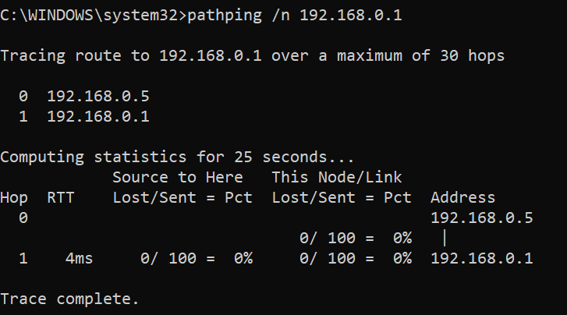

**(iii)pathping /w 3000 192.168.0.1 :**

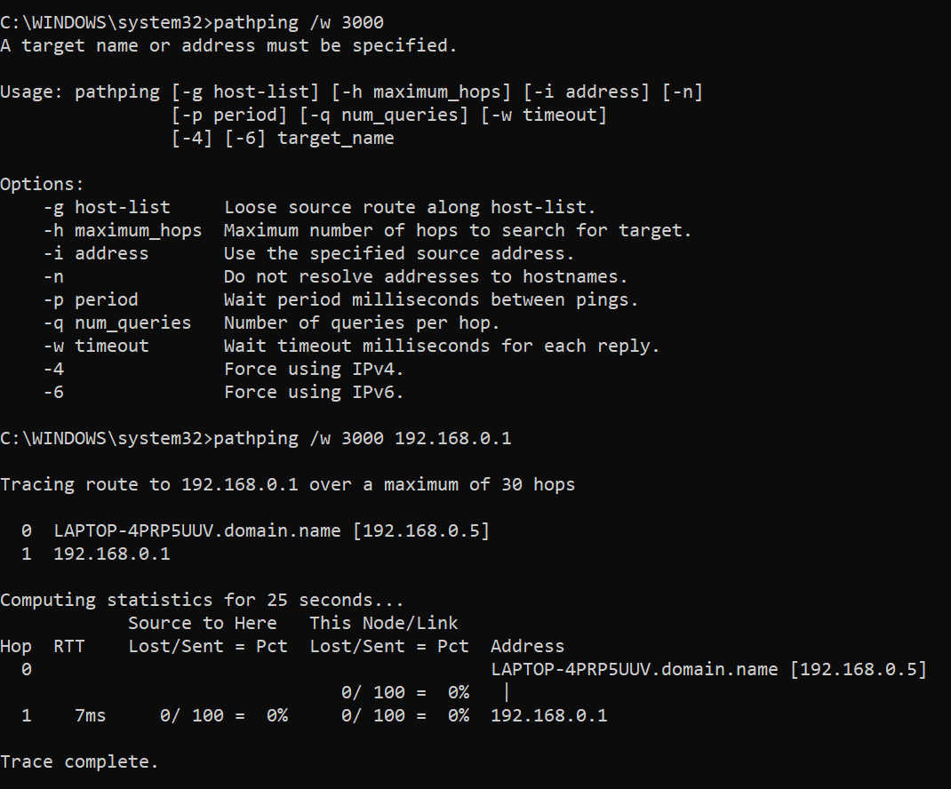

**7) systeminfo :**

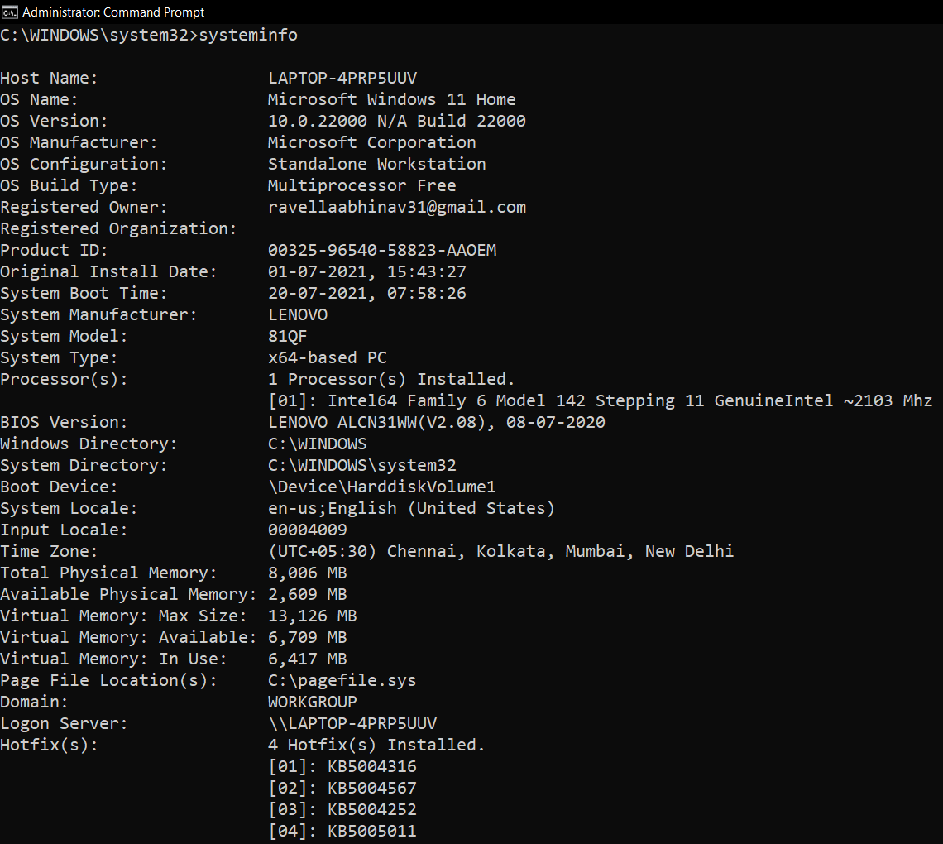

**8. netsh :**

1. **helper:**

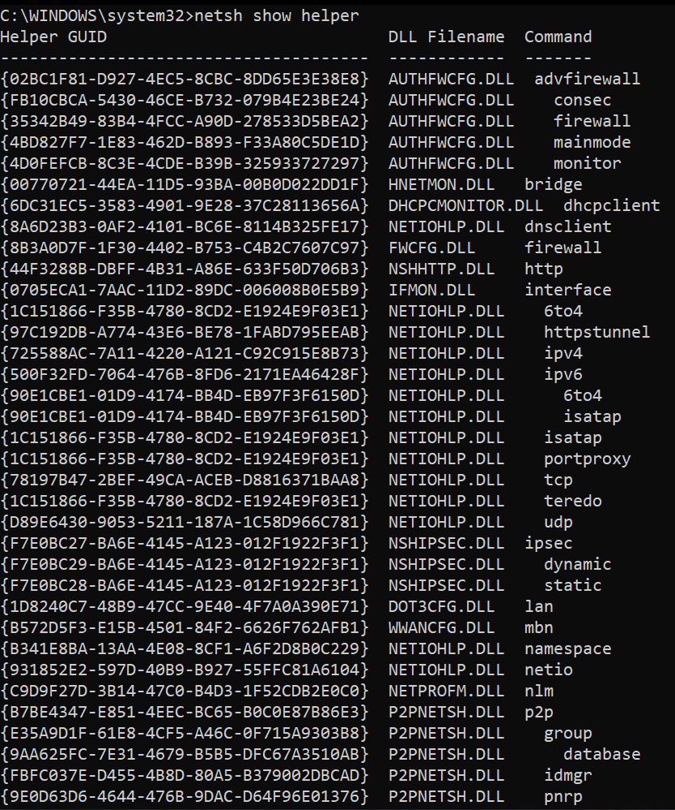

**(ii) netsh wlan show profile :**

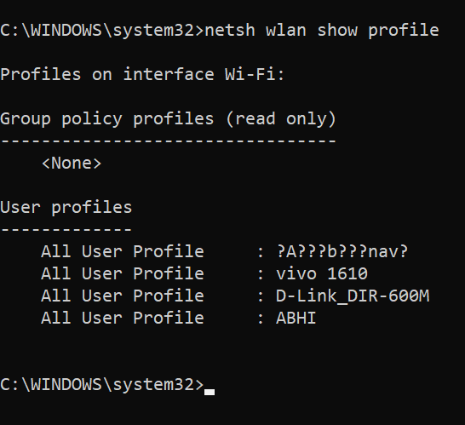

**(iii) netsh interface ipv6 show address :**

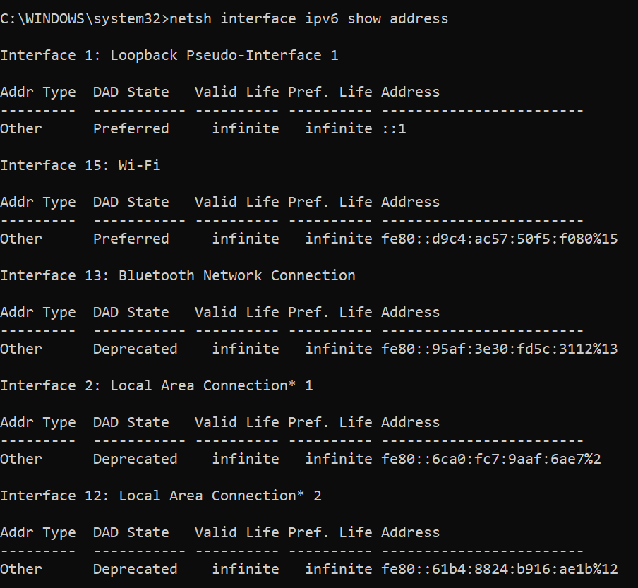

**(iv) netsh interface ipv4 show interface :**

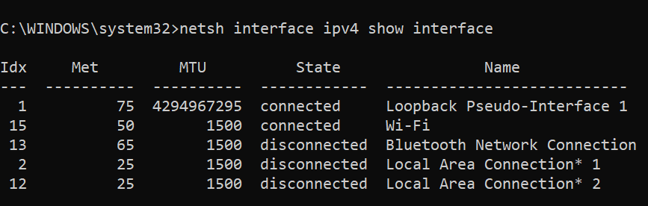

**10) tasklist :**

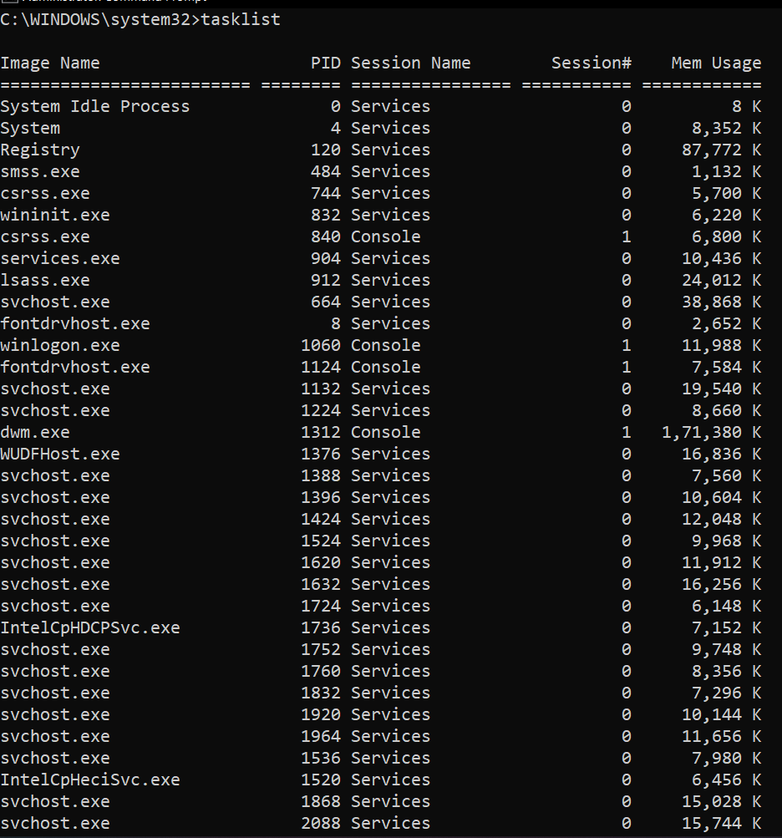

1. **tasklist /fi "status eq not responding" :**

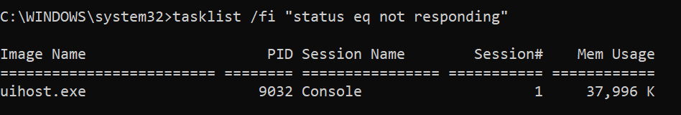

1. **tasklist /fi "cputime gt 07:25:00" :**

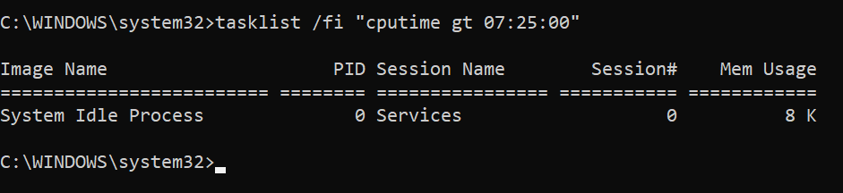

1. **tasklist /fi “pid eq 4” :**

